Mixed Models:
Both Species:
Model:
log1p(RespCorrectedWeight_GrCO2_KGr_Year)~ 1 + Species + DiamClass + Soil_moist + T3 + DensityKgM3, method="REML",na.action = na.omit, data=data, random=~1|Plot...16/SubPlot
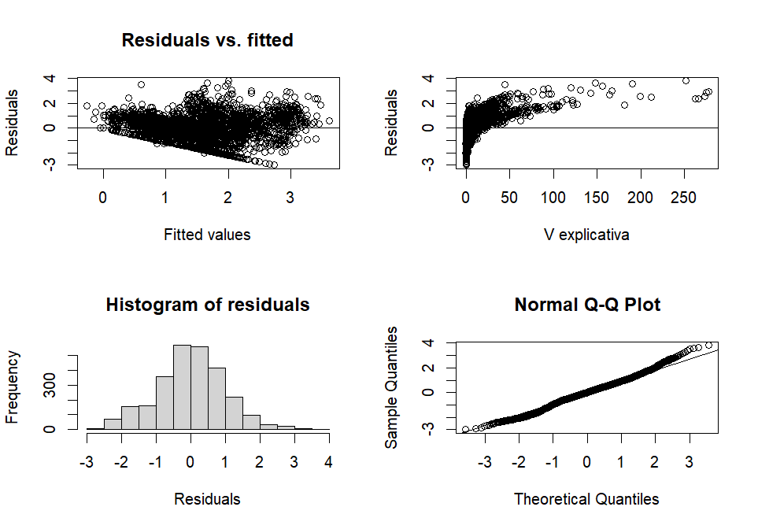
Lilliefors (Kolmogorov-Smirnov) normality test

data: Res
D = 0.033016, p-value = 4.206e-07

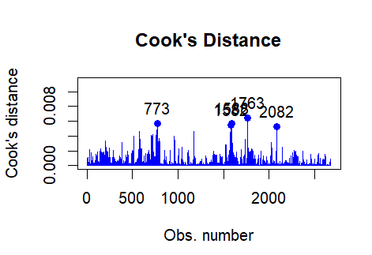

[1] 0.3737793
attr(,"adj.r.squared")
[1] 0.3908687

numDF denDF F-value p-value
(Intercept) 1 2657 433.8436 <.0001
Species 1 2657 52.3567 <.0001
DiamClass 1 2657 640.9654 <.0001
Soil_moist 1 2657 112.4078 <.0001
T3 1 2657 721.0705 <.0001
DensityKgM3 1 2657 56.7968 <.0001

Linear mixed-effects model fit by REML
Data: data
AIC BIC logLik
7206.845 7259.857 -3594.422

Random effects:
Formula: ~1 | Plot...16
(Intercept)
StdDev: 0.1258653
Formula: ~1 | SubPlot %in% Plot...16
(Intercept) Residual
StdDev: 0.03771735 0.9147731

Fixed effects: log1p(RespCorrectedWeight_GrCO2_KGr_Year) ~ 1 + Species + DiamClass + Soil_moist + T3 + DensityKgM3
 | Value | Std.Error | DF | t-value | p-value
(Intercept) | 1.320729 | 0.180109 | 2657 | 7.332939 | 0.00E+00
SpeciesFS | 0.292017 | 0.036516 | 2657 | 7.9969 | 0.00E+00
DiamClass | 0.041131 | 0.002109 | 2657 | 19.5029 | 0.00E+00
Soil_moist | -0.00021 | 5.95E-05 | 2657 | -3.59811 | 3.00E-04
T3 | 0.060659 | 0.002241 | 2657 | 27.06915 | 0.00E+00
DensityKgM3 | -0.00098 | 0.00013 | 2657 | -7.53637 | 0.00E+00
Correlation:
 | (Intr) | SpcsFS | DmClss | Sl_mst | T3
SpeciesFS | 0
DiamClass | -0.27 | -0.12
Soil_moist | -0.787 | 0.004 | -0.047
T3 | -0.3 | -0.024 | 0.014 | 0.239
DensityKgM3 | -0.372 | -0.243 | 0.49 | -0.041 | -3.00E-2
Standardized Within-Group Residuals:
Min Q1 Med Q3 Max
-3.01454453 -0.57752511 0.01277418 0.62857490 3.82989615
Number of Observations: 2677
Number of Groups:
Plot...16 SubPlot %in% Plot...16
3 15
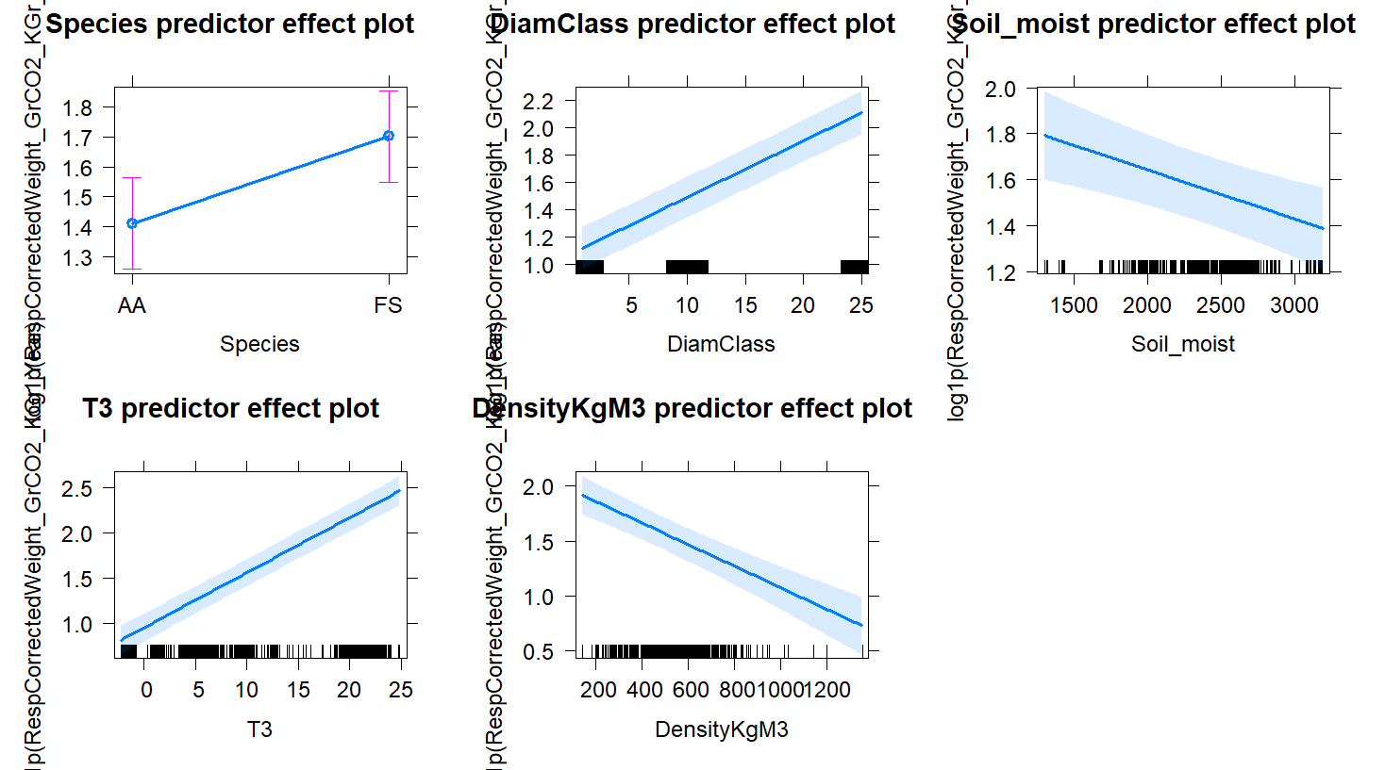
Fagus sylvatica:
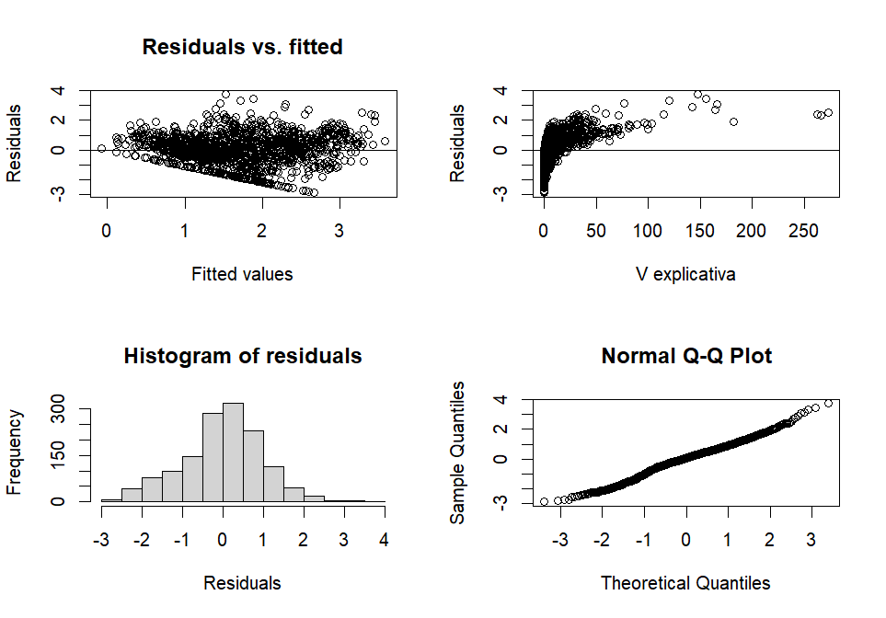
Lilliefors (Kolmogorov-Smirnov) normality test

data: Res
D = 0.048003, p-value = 5.762e-08

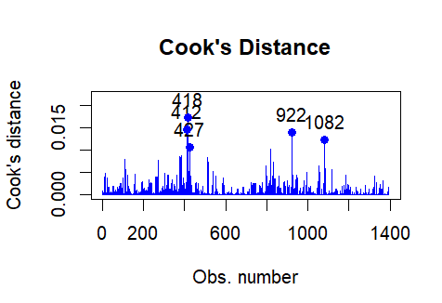
[1] 0.3527933
attr(,"adj.r.squared")
[1] 0.3692815
numDF | denDF | F-value | p-value
(Intercept) | 1 | 1375 | 660.3756 | <.0001
DiamClass | 1 | 1375 | 214.4646 | <.0001
Soil_moist | 1 | 1375 | 60.7005 | <.0001
T3 | 1 | 1375 | 436.1546 | <.0001
DensityKgM3 | 1 | 1375 | 49.5369 | <.0001

Linear mixed-effects model fit by REML
Data: data
AIC BIC logLik
3799.344 3841.235 -1891.672

Random effects:
Formula: ~1 | Plot...16
(Intercept)
StdDev: 0.1044624

Formula: ~1 | SubPlot %in% Plot...16
(Intercept) Residual
StdDev: 0.02590037 0.9207105

Fixed effects: log1p(RespCorrectedWeight_GrCO2_KGr_Year) ~ 1 + DiamClass + Soil_moist + T3 + DensityKgM3
 | Value | Std.Error | DF | t-value | p-value
(Intercept) | 1.713699 | 0.223434 | 1375 | 7.669824 | 0.00E+00
DiamClass | 0.032964 | 0.002826 | 1375 | 11.66319 | 0.00E+00
Soil_moist | -0.00018 | 7.71E-05 | 1375 | -2.396 | 1.67E-02
T3 | 0.065633 | 0.003101 | 1375 | 21.16491 | 0.00E+00
DensityKgM3 | -0.00123 | 0.000174 | 1375 | -7.03824 | 0.00E+00
Correlation:
(Intr) | DmClss | Sl_mst | T3
DiamClass | -0.271
Soil_moist | -0.805 | -0.061
T3 | -0.313 | 0.02 | 0.225
DensityKgM3 | -0.411 | 0.401 | -0.076 | -0.043

Standardized | Within-Group | Residuals:
 | Min | Q1 | Med | Q3 | Max
-2.8924 | -0.54337 | 0.062543 | 0.61635 | 3.771237

Number of Observations: 1394
Number of Groups:
Plot...16 SubPlot %in% Plot...16
3 15
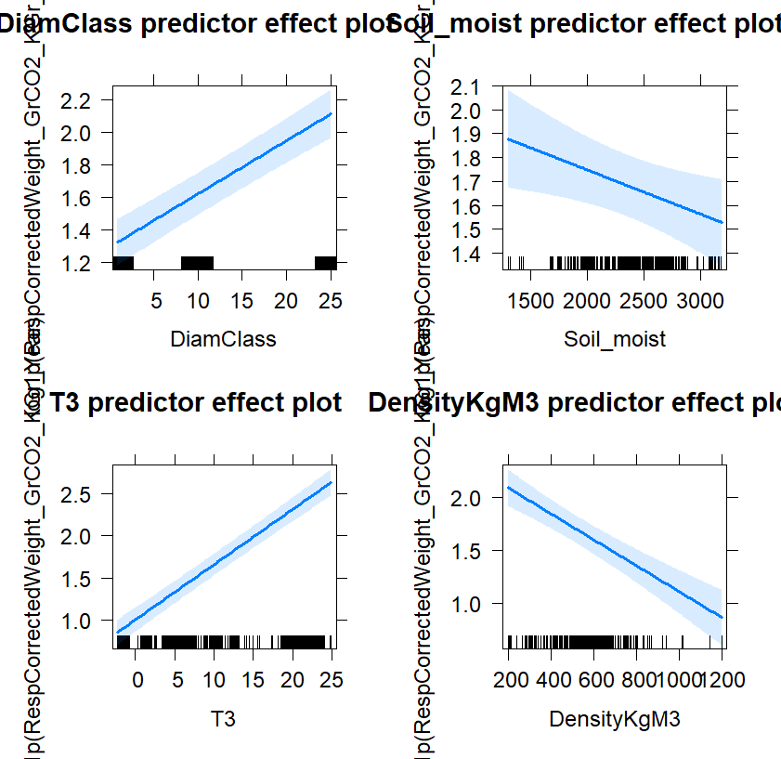
Abies Alba
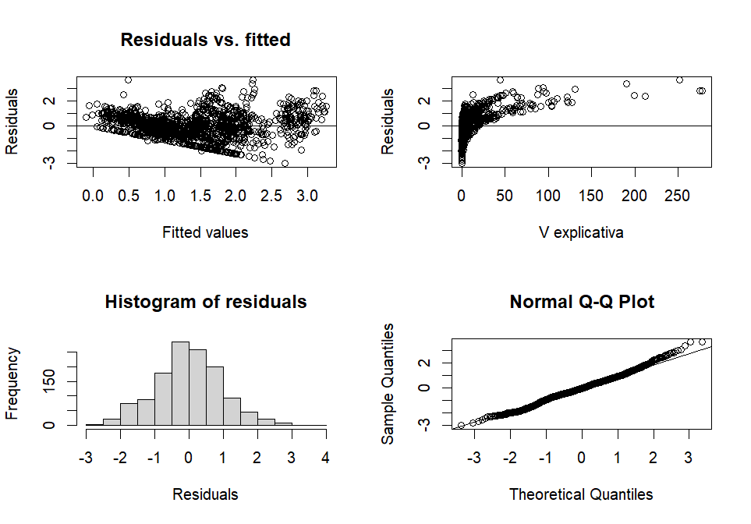
Lilliefors (Kolmogorov-Smirnov) normality test

data: Res
D = 0.030038, p-value = 0.008645

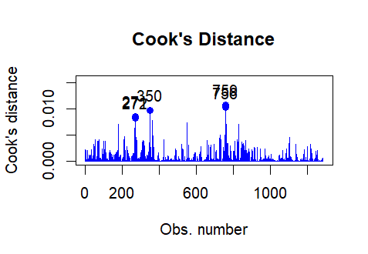

ANOVA  numDF | denDF | F-value | p-value
(Intercept) | 1 | 1264 | 251.0019 | <.0001
DiamClass | 1 | 1264 | 465.8703 | <.0001
Soil_moist | 1 | 1264 | 49.9971 | <.0001
T3 | 1 | 1264 | 297.0136 | <.0001
DensityKgM3 | 1 | 1264 | 6.7045 | 0.0097

Linear mixed-effects model fit by REML
Data: data
AIC BIC logLik
3441.818 3483.042 -1712.909

Random effects:
Formula: ~1 | Plot...16
(Intercept)
StdDev: 0.1479821

Formula: ~1 | SubPlot %in% Plot...16
(Intercept) Residual
StdDev: 0.07258697 0.8973787

Fixed effects: log1p(RespCorrectedWeight_GrCO2_KGr_Year) ~ 1 + DiamClass + Soil_moist + T3 + DensityKgM3
 | Value | Std.Error | DF | t-value | p-value
(Intercept) | 1.046289 | 0.263509 | 1264 | 3.970603 | 0.0001
DiamClass | 0.052604 | 0.00318 | 1264 | 16.54316 | 0
Soil_moist | -0.00022 | 8.91E-05 | 1264 | -2.49692 | 0.0127
T3 | 0.055326 | 0.003201 | 1264 | 17.28317 | 0
DensityKgM3 | -0.00051 | 0.000197 | 1264 | -2.5893 | 0.0097
Correlation:
(Intr) | DmClss | Sl_mst | T3
DiamClass | -0.324
Soil_moist | -0.815 | -0.032
T3 | -0.313 | 0.01 | 0.25
DensityKgM3 | -0.418 | 0.585 | -0.019 | -0.02

Standardized Within-Group Residuals:
Min Q1 Med Q3 Max
-2.9887208 -0.6052373 -0.0253497 0.6215762 3.6963976

Number of Observations: 1283
Number of Groups:
Plot...16 SubPlot %in% Plot...16
3 15

